Chapter 8, Solution 72.

When the switch is in position 1, we obtain IC=10 for the capacitor and IC=0 for the inductor. When the switch is in position 2, the schematic of the circuit is shown below.

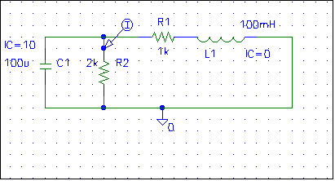

When the circuit is simulated, we obtain i(t) as shown below.

